Xbox Peripherals

This white paper discusses the low-level details of working with peripherals on the Xbox™ video game system from Microsoft, focusing primarily on the Xbox Controller that ships with the North American and European Xbox console (the controller formerly code named "Duke"). Unless noted otherwise, the information presented herein also applies to the Xbox Controller S that ships with the Japanese version of the console (the controller formerly code named "Akebono").
The Xbox Game Controller
Digital Buttons
There's not really too much to say about the digital buttons. They work as you would expect them to. There are four digital buttons on the Xbox Controller: START, BACK, and the left and right thumbstick, all of which can be depressed. The state of these buttons is stored in the wButtons field of the XINPUT_GAMEPAD structure when you query the controller state using XInputGetState.
It is important to note that usability research has indicated that users can accidentally depress the digital thumbstick buttons during normal use. Another issue with the digital thumbstick buttons is that the user can inadvertently release a button when moving the thumbstick while it is depressed. Keep these facts in mind when designing the input model of your game; in general, try not to use a thumbstick for both movement and a button press.
The D-Pad
Again, there's not too much to say about the D-pad of the Xbox Controller. It works as you would expect it to. Conceptually, the D-pad is four distinct digital buttons. The state of the D-pad is reported in the same field of the XINPUT_GAMEPAD structure as the other digital buttons. You can safely assume that you will never receive a notification that UP and DOWN are pressed at the same time, or that LEFT and RIGHT are pressed at the same time.
Because the D-pad gives only four distinct readings, a diagonal D-pad position is reported as two neighboring positions. For instance, northeast would be represented as UP and RIGHT. But UP and RIGHT are separate digital buttons and will never be pressed at exactly the same time. The controller will detect either UP or RIGHT before detecting the other. Take this into account when designing your input model; do not assume the player can move from center to a diagonal position in one step.
Analog Buttons
There are eight analog buttons on the Xbox Controller: A, B, X, Y, Black, and White (and the left and right triggers, which are documented below). The firmware reports the state of an analog button as a value in the range of 0 (not pressed) to 255 (maximum pressure). The state of these buttons is stored in the bAnalogButtons field of the XINPUT_GAMEPAD structure when you query the controller state using XInputGetState.
While the state of a button can contain 255 unique values, the controller will report only around 70 discrete values (scaled to the 0–255 range) for a given button.
Snapover
When the user initially presses an analog button, there is some snapover. That is, it will take some force before the button registers a press. From the time the user starts pressing the button until the button hits the mechanical snapover, the firmware reports 0. When the button hits the snapover, the first reading will not be 1.
Even though the range of values spans from 0 to 255, the lower end of this range is hard to achieve. The analog button sits on a dome. When you first press the button, the dome compacts (to about 120), then expands a little (to about 60). At this point, you can compress to 255 or back up to 0, until the dome pops back out.
With use, the dome will wear, and the snapover will result in an initial reading as low as 60 (as opposed to the 120 snapover reported by a new controller). This generally happens after about 100,000 or so presses of the button.
The following chart shows the relationship between the physical pressure that is applied to the button (shown in red) and the value that is reported by the system (shown in blue).
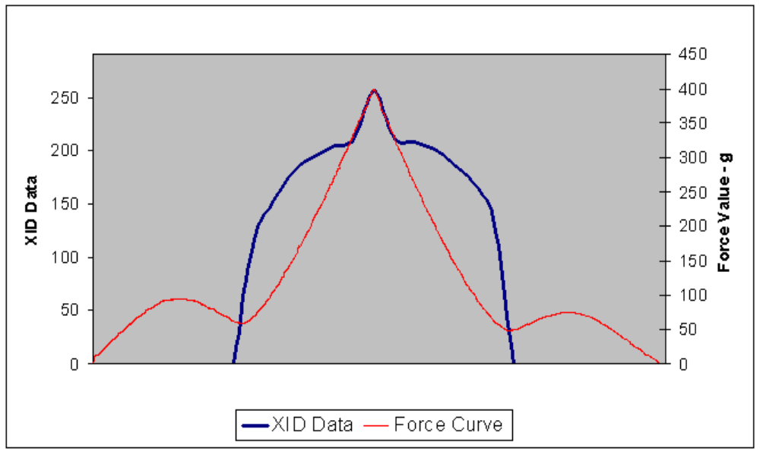
Notice how the readings are affected when the button reaches the snapover point. Even though you are applying pressure, the system reports a value of zero.
Also notice the spike at the top of the curve. At this point, the dome has reached its maximum compression and the pressure being exerted on the button is applied directly to the sensor underneath.
Crosstalk
On some Xbox Controllers, when an analog button is pressed, other analog buttons on that controller may register a value above zero even though they are not depressed. This phenomenon is known as crosstalk. The maximum expected crosstalk seems to be about 30. There is a constant defined in the library called XINPUT_GAMEPAD_MAX_CROSSTALK. The title should ignore any value less than or equal to XINPUT_GAMEPAD_MAX_CROSSTALK that is reported by any analog button. And rather than using a range of 0 to 255 for acceptable analog button values, your title should take action only if the value reported by an analog button is in the range of XINPUT_GAMEPAD_MAX_CROSSTALK to 255.
Analog Triggers
There are two analog triggers on the Xbox Controller. The firmware will report the state of a trigger as a value in the range of 0 (not pressed) to 255 (fully depressed). While the range contains 255 unique values, the controller will initially report only around 150 discrete values (scaled to the 0 to 255 range). As the trigger is used, the resolution increases, and the controller will report more than 150 discrete values. But the controller will never report 255 discrete values, no matter how much the trigger is used.
Thumbsticks
There are two thumbsticks on the Xbox Controller. The firmware will report the state of a thumbstick as a value in the range of –32768 (fully left or up) to 32767 (fully right or down). While the range contains 65536 unique values, the controller will initially report only around 120 discrete values (scaled to the –32768 to 32767 range). As the thumbstick is used, the resolution increases, and the controller can report as many as (approximately) 160 discrete values.
Dynamic Calibration
When a user first connects the Xbox Controller or turns on the console, the resolution of the thumbsticks is limited. The Xbox Controller's firmware assumes that the thumbstick has about half of the freedom of movement that it actually has. As the Xbox Controller is used, the thumbsticks move beyond these assumed limits, and these new positions replace the initial estimated extremes as the new assumed extremes. This process repeats until the thumbstick hits the plastic casing of the Xbox Controller and can move no further. At that point, the assumed extremes correlate to the actual, physical limits of the hardware.
The underestimation and resampling are done to overcome minor manufacturing variations from controller to controller. The usable range of the thumbstick extends beyond the limits imposed by the casing of the Xbox Controller. When the circuitry of the Xbox Controller is placed inside of the casing, the thumbsticks will never be exactly centered (although they are well within the accepted manufacturing deviation). By determining the limits of the thumbstick's motion as the controller is used, the firmware can ensure that every Xbox Controller will behave in exactly the same way (even though no two controllers are exactly alike).
The following chart shows the center position error, the default calibration range, the dynamic calibration range, and the (quite unreachable) joystick maximum range. Values are given in degrees, firmware counts, and XID counts.

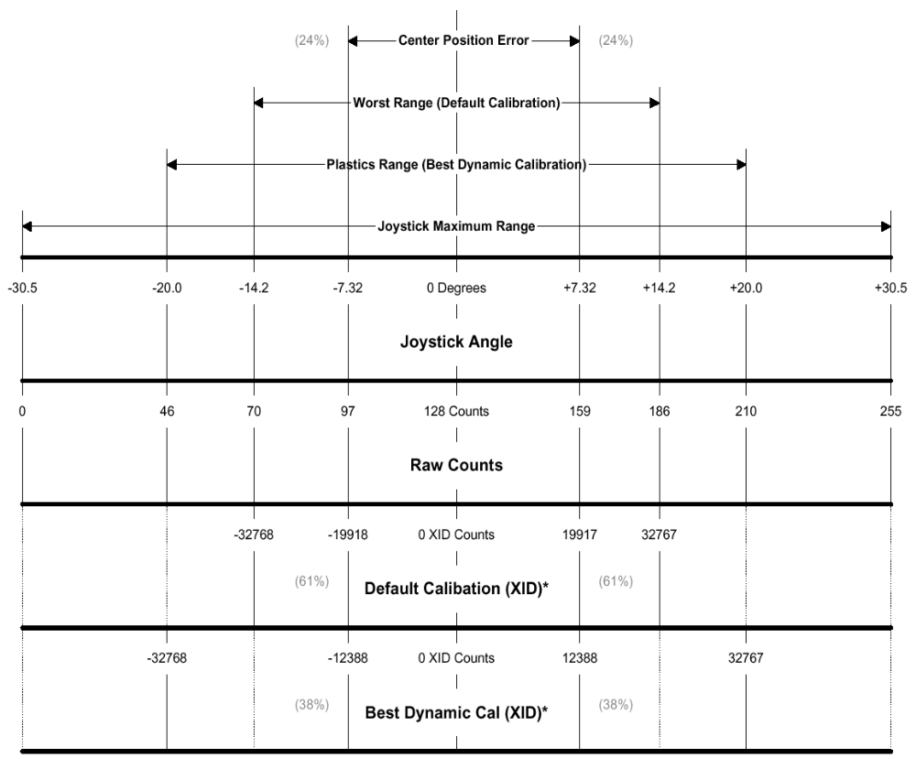
*Both the Default Calibration and the Dynamic Calibration have seven buffer counts inside of the endpoints of the calibration; for any raw value in that range, the output will be +32767 or –32768.
In other words, the output will hit maximum value seven counts before reaching either endpoint of the calibration.
Pay special attention to the Default Calibration and the Best Dynamic Cal sections. Notice how the center position error shrinks after calibration and how the reported range (Joystick Angle related to XID Counts) increases after calibration.
Dead Center
Thumbsticks never really come to rest in the exact center of their movable range. Because of manufacturing variations, the thumbstick can come to rest slightly to the left, right, top, or bottom of center. Another culprit in this off-centeredness is a phenomenon known as hysteresis. Hysteresis is a term used to describe the change in center position of the thumbstick when the thumbstick comes to rest from different directions. The physical properties of the thumbstick apparatus may cause the thumbstick to come to rest in a slightly different position if it is released from the extreme left than it would if released from the extreme right. The same is true for the top and bottom extremes, and for any combination thereof.
On power up, the actual center position of the thumbstick lies somewhere within the center 61 percent of the usable range. As the thumbstick is used and the resolution of the range of allowable values increases, the range of values that the center position can occupy drops to about 20 percent. In other words, dynamic calibration eliminates the error introduced by manufacturing variations (about 41 percent) and leaves only the error attributed to hysteresis (about 20 percent).
In general, the numbers quoted above should be worst-case scenarios. You can easily find Xbox Controllers that have much smaller center position errors (some smaller than 10 percent after dynamic calibration).
The Dead Zone
Unfortunately, there is no way to know whether or not the controller's firmware has calibrated a thumbstick. Calls to XInputGetState will always return the thumbstick position in the range –32768 to 32767, regardless of calibration. The dead zone is the area of the thumbstick that your title treats as center, and the title takes no action when the thumbstick lies within this zone. This area is some percentage of the usable area. Because the usable area grows as the thumbstick is calibrated, the dead zone grows with it. Before calibration, the center position may lie outside of the dead zone (because it is smaller before calibration), which may cause some drift. How you handle that drift is entirely up to you. There is no general solution that will work for all games.
One solution might be to design the initial game menus so that the user moves the thumbstick from extreme to extreme before beginning any actual gameplay. The problem with this solution is that the user may add a new controller or replace an existing controller during the game. When a new controller is added, it is initially uncalibrated.
In some games, such as racing titles, drift may not be a concern. After all, a little drift is natural in a car, and the amount of drift is greatly reduced (or eliminated) after dynamic calibration. Other games, such as puzzle titles, can bypass the initial drift by using a larger dead zone. Puzzle titles generally don't need as much thumbstick resolution as other titles and will likely treat the thumbstick much like a D-pad anyway.
It is entirely up to you to decide how your title will handle dead zones before and after calibration. See the Technical Certification Sample for an example of switching dead zones. The Technical Certification Sample has two deadzones: one at X% and one at Y%. It initially uses X% as the deadzone. Once it determines that the stick has been pressed fully in all directions, it switches to Y%.
Vibration
There are two vibration motors on the Xbox Controller. The wLeftMotorSpeed and wRightMotorSpeed fields of the XINPUT_RUMBLE structure are used when calling XInputSetState to control the speed of the motors. These fields can contain a value in the range of 0x0000 (no motor use) to 0xFFFF (100-percent motor use).
In general, a motor at rest will not be set in motion by values below a certain threshold (although the motor may make a humming noise). Once the motor is in motion, the value can be dropped back down below this threshold without stopping the motor.
The left (low frequency) and right (high frequency) motors behave differently. The left motor starts spinning with a value of approximately 0x4268 and stops at about 0x1B58. The maximum rotations per minute for the left motor are about 2561 rpm.
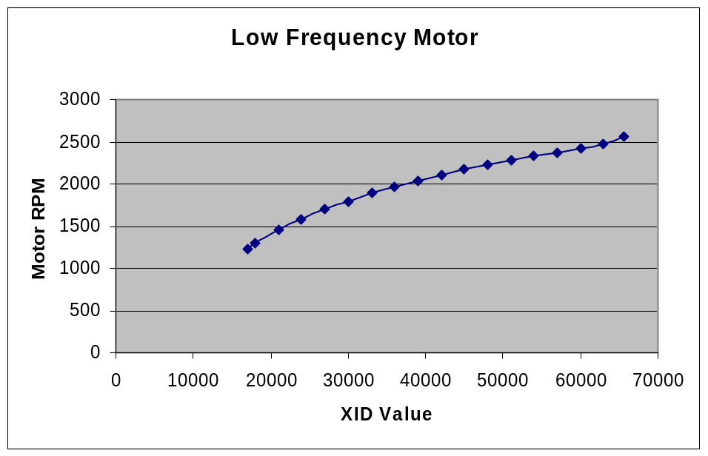
The right motor starts spinning with a value of approximately 0x34BC and stops at about 0x2134. The maximum rotations per minute for the right motor are about 4658 rpm.
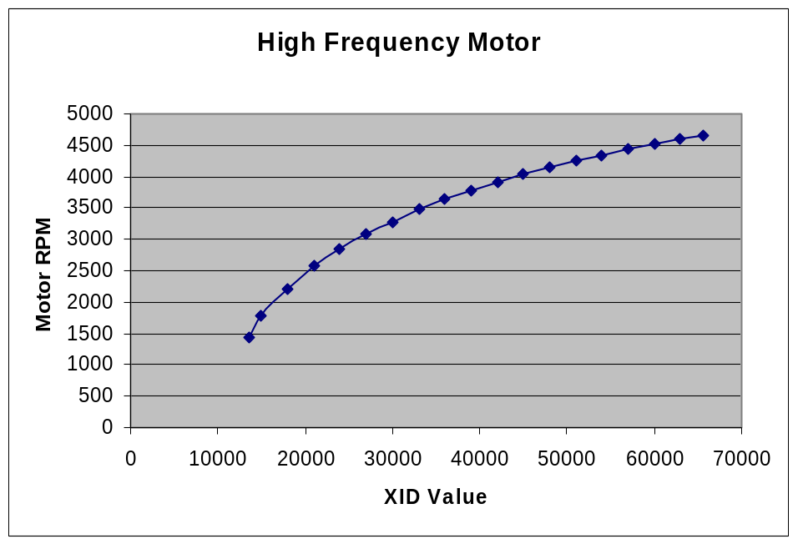
Data Acquisition and Input Report Latency
Data Acquisition
The Xbox Controllers acquire data in an executive loop. This loop is responsible for debouncing the digital buttons and reading the position of the analog buttons and thumbsticks from the analog-to-digital converters (ADCs). The details of this process have been tweaked to balance a number of competing goals: high precision, high repeatability, high responsiveness, low jitter, low cross-talk, and others. The result is a data acquisition loop that takes four milliseconds to produce a state packet of the device. This packet is the XINPUT_GAMEPAD. After the packet is complete, it is copied to a buffer for transmission across the USB wire, replacing the current state packet. This loop is not synchronized with the USB frame clock; the importance of this fact will be discussed later. For the sake of discussion, zero latency would mean that this data is available to the game as soon as this loop generates the packet.
Data Transmission
The USB interrupt pipe is a hardware-polled architecture. When software posts a request for data, the host hardware polls the device at a fixed interval (configurable by software) until the device responds with new data. The hardware polling interval is synchronous with the one-millisecond USB frame. This starts when the USB hardware is initialized with XInitDevices. When new data is received, the host hardware generates an interrupt, which is handled by the USB subsystem of the Xbox System Software. The Xbox Input Device (XID) subsystem is eventually called in the context of the interrupt's dispatch routine, where it copies the packet into a state buffer (of type XINPUT_STATE) and increments the dwPacketNumber member of the buffer. Notice that this entire process happens (essentially) while servicing interrupts and does not affect any of the game title's threads. The game controller will transmit the same data only once. Thus, after the state is transmitted, the device will be silent until the executive loop completes again and posts a different data packet.
The XInput API and Polling Modes
From the time a device is opened with XInputOpen, the XID subsystem always maintains a buffer of the last known state of the device. As mentioned above, this buffer is updated in response to interrupts, and dwPacketNumber is incremented whenever it changes. XInputGetState always copies that buffer into the caller's buffer and returns immediately.
XInputOpen, particularly the pPollingParameters argument, and XInputPoll can be used to control the way the state buffer is maintained. Two fields are relevant for input: fAutoPoll and bInputInterval. The other fields are discussed below in the section on output. Passing NULL for pPollingParameters effectively sets fAutoPoll to TRUE and bInputInterval to 8. bInputInterval is the fixed hardware polling interval discussed above. The hardware can poll only at intervals of 1, 2, 4, 8,16, or 32 milliseconds, so bInputInterval is rounded down to the nearest value.
AutoPoll
If fAutoPoll is TRUE, the XID subsystem requests input automatically. This means that before XInputOpen returns, a request is submitted to the hardware to get data. In the interrupt processing, when data is retrieved, the request is resubmitted to continue getting data. The net effect is that the hardware is always being polled at bInputInterval (appropriately rounded down).
What is the latency in the auto poll case? First, there is the bInputInterval. Because hardware polling is synchronized with the USB frame and data acquisition is not, the delay between the completion of data acquisition and the next poll is random. The poll may come immediately after the loop completes, or it may take up to bInterval milliseconds. Furthermore, if bInterval is greater than four milliseconds, entire packets may get thrown away.
Before you loose any sleep over this, you must first decide if you could have used this data anyway. It is nearly impossible for a user to a press a button for a duration of under about 20 milliseconds anyway, and if they did, there is a good chance that they just nicked it by mistake while trying to press a different one. The thumbsticks move continuously and there is no need to acquire the position more often than your game can process it anyway.
The second source of latency is from the time the interrupt is raised until the new data is copied into the state buffer. This time span is more difficult to quantify. On an otherwise idle system, this process will typically require about a millisecond (USB only raises interrupts on the start of a one-millisecond frame). However, with lots of other interrupt processes (especially DVD, hard disk, and audio) occurring in the background, this latency could be longer. A very conservative upper bound is about two milliseconds. Finally, there is the time between when the state buffer is updated and when the game calls XInputGetState and begins processing the data. This latency depends on how often the game calls XInputGetState.
So, in the default polling mode (that is, bInterval is 8 milliseconds), the typical latency will be about 12 to 13 milliseconds for a game calling XInputGetState every 16 milliseconds. The best case will be under 1 millisecond, and the worst case will be about 25 to 26 milliseconds. Keep in mind that it is difficult to compare these numbers to other systems, as we have carefully laid out all the factors and what affects them.
ManualPoll
If fAutoPoll is FALSE, XInputPoll must be called to submit a data request. XInputOpen still acquires the initial state of the device (through a non-interrupt mechanism), but now the state of the device will not be updated without regular calls to XInputPoll. At this point, you should have enough information to figure out all the scenarios and calculate the best and worst case latency, and so on. The one interesting case is using manual polling to synchronize with the video frame while reducing interrupts.
In this case, you would set fAutoPoll to FALSE and set bInterval to one millisecond. Then you must arrange to call XInputPoll about two to three milliseconds before the end of the game's render loop. This assumes that the game starts each render loop by acquiring state and calculating new physics based on the state of the controller. When XInputPoll is called, a request is posted. The hardware will be polled within a millisecond. If there is any new data to report, it will be reported at that time. The interrupt will be raised and processed within one to two milliseconds. The next call to XInputGetState will retrieve the freshest data available, with a latency of only about two to three milliseconds. Furthermore, because you submit requests only at your game's frame rate, there are no extraneous interrupts providing data that gets discarded anyway. (The USB CPU overhead is so low though, you probably won't notice unless the game really pushes the CPU limits already.)
The big caveat here is that the call to XInputPoll has to be placed very judiciously. If it is called too late, you will always be a frame behind. If it called too soon, the latency is slightly larger.
Vibration
Vibration has two options for transmission. One is USB interrupt output; the other is USB control output. Like interrupt input, interrupt output works on a fixed schedule. This guarantees that if XInputOpen succeeds, you will be to send data at the specified interval. Control output is not scheduled and sends the data as soon as possible. In either case, the firmware adjusts the vibration motor outputs as soon as it receives the data.
On a bus with little control or bulk traffic, such as an Xbox with the currently available peripherals, control output is transmitted within microseconds and provides much better performance. (The only exception may be when trying to manipulate the vibration motors while writing to a couple memory units simultaneously. This is strongly discouraged anyway.) Thus, control output is the default. This can be overridden by changing fInterruptOut in the pPollingParameters argument to XInputOpen. If fInterruptOut is TRUE, bOutputInterval sets the interval as it does in the interrupt input case. Calculating the latencies is left as an exercise.
USB Bus Bandwidth
Control data and bulk data, used by USB enumeration, the memory units, and possibly for vibration output, is unscheduled and the bandwidth is unreserved. The data is submitted and transmitted on a priority system that is close to first in, first out (FIFO). (Control has a slightly higher priority. And in really busy conditions, small transmissions may go before longer ones that were submitted earlier.)
Interrupt (game controller input) and isochronous (used by the voice peripheral) bandwidth is reserved when a device is opened. So for example, when XInputOpen succeeds, it is guaranteed that input data will always be transmitted without delay. This always leaves open the possibility that the schedule will fill up. In this case, XInputOpen would fail. The amount of bandwidth required is determined by bInputInterval and bOutputInterval (only if fInterruptOut is TRUE). If bInputInterval is smaller, more bandwidth must be reserved (even in the manual polling cases). With four game controllers on the system, it should be possible to open all four controllers with a one-millisecond polling interval on input and output, and still use only about a quarter of the available bandwidth. However, in the future (with voice peripherals for example), there may be a need to be more careful.
CPU Overhead
The overhead of this process is minimal. Most of the time, the USB host hardware is doing the work without using any other system resources. The interrupt processing occurs in two steps. First, the interrupt occurs, and only a few instructions are executed to disable USB interrupts and queue a DPC request (a driver concept from Microsoft® Windows NT®). The DPC routine notifies the proper subsystem that its data transfer is complete and allows the subsystem to do any additional processing. We have not done extensive profiling of this process, but we can place an upper bound of about one eighth of one percent of CPU utilization for a single game controller in continuous use, with the default polling parameters. Adding additional controllers will increase this, but negligibly.
Other Controllers
The Xbox Controller that ships with the Xbox console is not the only type of controller that will be used. To query a controller for its capabilities, call XInputGetCapabilities.
If the user plugs in a steering wheel peripheral or a light gun peripheral, XInputGetCapabilities could be used to determine that a certain button is missing, and the title could handle it accordingly. XInputGetCapabilities can also be used to determine the resolution of the analog components of the controller. If the title expects a certain resolution of input values for an analog button, thumbstick, or trigger, you can easily determine the current controller's capabilities and scale the inputs as needed.
There is no need to try to support every possible peripheral subtype, but it may make sense to add a controller translation layer to the title to help map game functions to different controller types.
For a list of controller subtypes and how they map to one another, please see the Custom Controller Key Mapping Defaults section of the “Xbox Third-Party Peripheral Requirements” document on the Xbox developer Web site at http://xds.xbox.com.
You should always check the subtype of the controller using XInputGetCapabilities to determine the layout of the current controller. Even the standard Xbox Controller (XINPUT_DEVSUBTYPE_GC_GAMEPAD) and the Xbox Controller S (XINPUT_DEVSUBTYPE_GC_GAMEPAD_ALT) have different button layouts.

